Тема № 7
Векторный редактор
Цель работы: получить практические навыки разработки иерархии классов сложных проектов, получить опыт применения команд графики и работы с бинарными файлами объектов данных для сохранения и загрузки построенных векторных изображений.
Задача (16 вариант):
Квадрат, прямоугольник, крестообразная фигура, П-образная фигура | Заливка фигуры
Задание:
Код классов всех фигур, а также их менеджера для их управлением, а также буфером обмена
Figure.cs
using System;
using System.Drawing;
using System.Drawing.Drawing2D;

[Serializable]
public abstract class Figure
{
public Rectangle Bounds { get; set; }
public Stroke Stroke { get; set; }
public Color FillColor { get; set; }

protected Figure(Rectangle bounds, Stroke stroke, Color fillColor)
{
Bounds = bounds;
Stroke = stroke ?? new Stroke();
FillColor = fillColor;
}

public abstract void Draw(Graphics g);
public abstract bool HitTest(Point point);
public abstract Figure Clone();

public void Move(int dx, int dy)
{
Bounds = new Rectangle(Bounds.X + dx, Bounds.Y + dy, Bounds.Width, Bounds.Height);
}

public void MoveTo(Point newLocation)
{
Bounds = new Rectangle(newLocation, Bounds.Size);
}

protected Pen GetPen() => Stroke.UpdatePen(new Pen(Color.Black));
protected Brush GetFillBrush() => new SolidBrush(FillColor);
}
Stroke.cs
using System;
using System.Drawing;
using System.Drawing.Drawing2D;

[Serializable]
public class Stroke
{
public Stroke()
{
Color = Color.Black;
Width = 1f;
DashStyle = DashStyle.Solid;
}

public Color Color { get; set; }
public float Width { get; set; }
public DashStyle DashStyle { get; set; }

public Pen UpdatePen(Pen pen)
{
if (pen == null) throw new ArgumentNullException(nameof(pen));
pen.Color = Color;
pen.Width = Width;
pen.DashStyle = DashStyle;
return pen;
}
}
FigureManager.cs
using System;
using System.Collections.Generic;
using System.Drawing;
using System.IO;
using System.Linq;
using System.Runtime.Serialization;
using System.Runtime.Serialization.Formatters.Binary;

public class FigureManager
{
private List<Figure> _figures;
private Figure _selectedFigure;
private readonly StackMemory _undoStack;
private readonly StackMemory _redoStack;
private Figure _clipboardFigure;

public FigureManager(int undoDepth = 20)
{
_figures = new List<Figure>();
_undoStack = new StackMemory(undoDepth);
_redoStack = new StackMemory(undoDepth);
}

public IReadOnlyList<Figure> Figures => _figures;
public Figure SelectedFigure => _selectedFigure;

public event Action StateChanged;

private void SaveStateToUndo()
{
using (var ms = new MemoryStream())
{
SerializeToStream(ms, _figures);
_undoStack.Push(ms);
}
_redoStack.Clear();
StateChanged?.Invoke();
}

private void RestoreFromStack(StackMemory stack, StackMemory otherStack)
{
if (stack.Count == 0) return;
using (var ms = new MemoryStream())
{
// сохраняем текущее состояние в другой стек
using (var currentMs = new MemoryStream())
{
SerializeToStream(currentMs, _figures);
otherStack.Push(currentMs);
}
// восстанавливаем из выбранного стека
stack.Pop(ms);
_figures = DeserializeFromStream(ms).ToList();
_selectedFigure = null;
StateChanged?.Invoke();
}
}

public void Undo() => RestoreFromStack(_undoStack, _redoStack);
public void Redo() => RestoreFromStack(_redoStack, _undoStack);

public void AddFigure(Figure figure)
{
SaveStateToUndo();
_figures.Add(figure);
SelectFigure(figure);
}

public void RemoveFigure(Figure figure)
{
if (figure == null) return;
SaveStateToUndo();
_figures.Remove(figure);
if (_selectedFigure == figure) _selectedFigure = null;
}

public void SelectFigure(Figure figure)
{
_selectedFigure = figure;
StateChanged?.Invoke();
}

public void SelectFigureAtPoint(Point point)
{
var hit = _figures.LastOrDefault(f => f.HitTest(point));
SelectFigure(hit);
}

public void MoveSelectedFigure(int dx, int dy)
{
if (_selectedFigure == null) return;
SaveStateToUndo();
_selectedFigure.Move(dx, dy);
StateChanged?.Invoke();
}

public void UpdateStrokeOfSelected(Color color, float width)
{
if (_selectedFigure == null) return;
SaveStateToUndo();
_selectedFigure.Stroke.Color = color;
_selectedFigure.Stroke.Width = width;
StateChanged?.Invoke();
}

public void UpdateFillOfSelected(Color fillColor)
{
if (_selectedFigure == null) return;
SaveStateToUndo();
_selectedFigure.FillColor = fillColor;
StateChanged?.Invoke();
}

public void CopySelected()
{
if (_selectedFigure != null)
_clipboardFigure = _selectedFigure.Clone();
}

public void CutSelected()
{
if (_selectedFigure == null) return;
CopySelected();
RemoveFigure(_selectedFigure);
_selectedFigure = null;
}

public void Paste(Point offset)
{
if (_clipboardFigure == null) return;
var newFigure = _clipboardFigure.Clone();
newFigure.Move(offset.X, offset.Y);
AddFigure(newFigure);
}

public void ClearAll()
{
SaveStateToUndo();
_figures.Clear();
_selectedFigure = null;
}

public void SaveToFile(string filename)
{
using (var fs = new FileStream(filename, FileMode.Create))
SerializeToStream(fs, _figures);
}

public void LoadFromFile(string filename)
{
using (var fs = new FileStream(filename, FileMode.Open))
{
var loaded = DeserializeFromStream(fs).ToList();
SaveStateToUndo();
_figures = loaded;
_selectedFigure = null;
StateChanged?.Invoke();
}
}

private void SerializeToStream(Stream stream, List<Figure> list)
{
var formatter = new BinaryFormatter();
formatter.Serialize(stream, list);
stream.Position = 0;
}

private static IEnumerable<Figure> DeserializeFromStream(Stream stream)
{
try
{
var formatter = new BinaryFormatter();
stream.Position = 0;
return (List<Figure>)formatter.Deserialize(stream);
}
catch (SerializationException)
{
return new List<Figure>();
}
}
}
StackMemory.cs
using System;
using System.Collections.Generic;
using System.IO;

[Serializable]
public class StackMemory
{
private readonly int _stackDepth;
private readonly List<byte[]> _list = new List<byte[]>();

public StackMemory(int depth)
{
_stackDepth = depth < 1 ? 1 : depth;
_list.Clear();
}

public void Push(MemoryStream stream)
{
if (_list.Count >= _stackDepth)
_list.RemoveAt(0);
_list.Add(stream.ToArray());
}

public void Clear() => _list.Clear();
public int Count => _list.Count;

public void Pop(MemoryStream stream)
{
if (_list.Count == 0) return;
byte[] buff = _list[_list.Count - 1];
stream.Write(buff, 0, buff.Length);
_list.RemoveAt(_list.Count - 1);
}
}
Square.cs
using System;
using System.Collections.Generic;
using System.Linq;
using System.Text;
using System.Threading.Tasks;
using System.Drawing;

[Serializable]
public class Square : Figure
{
public Square(Rectangle bounds, Stroke stroke, Color fillColor)
: base(new Rectangle(bounds.X, bounds.Y, bounds.Width, bounds.Width), stroke, fillColor) { }

public override void Draw(Graphics g)
{
using (var pen = GetPen())
using (var brush = GetFillBrush())
{
if (FillColor != Color.Transparent)
g.FillRectangle(brush, Bounds);
g.DrawRectangle(pen, Bounds);
}
}

public override bool HitTest(Point point) => Bounds.Contains(point);

public override Figure Clone() => new Square(Bounds, new Stroke { Color = Stroke.Color, Width = Stroke.Width }, FillColor);
}
RectangleFigure.cs
using System;
using System.Collections.Generic;
using System.Linq;
using System.Text;
using System.Threading.Tasks;
using System.Drawing;

[Serializable]
public class RectangleFigure : Figure
{
public RectangleFigure(Rectangle bounds, Stroke stroke, Color fillColor) : base(bounds, stroke, fillColor) { }

public override void Draw(Graphics g)
{
using (var pen = GetPen())
using (var brush = GetFillBrush())
{
if (FillColor != Color.Transparent)
g.FillRectangle(brush, Bounds);
g.DrawRectangle(pen, Bounds);
}
}

public override bool HitTest(Point point) => Bounds.Contains(point);

public override Figure Clone() => new RectangleFigure(Bounds, new Stroke { Color = Stroke.Color, Width = Stroke.Width }, FillColor);
}
CrossFigure.cs
using System;
using System.Drawing;
using System.Drawing.Drawing2D;
using System.Threading.Tasks;

[Serializable]
public class CrossFigure : Figure
{
public CrossFigure(Rectangle bounds, Stroke stroke, Color fillColor) : base(bounds, stroke, fillColor) { }

public override void Draw(Graphics g)
{
using (var path = GetPath())
using (var pen = GetPen())
using (var brush = GetFillBrush())
{
if (FillColor != Color.Transparent)
g.FillPath(brush, path);
g.DrawPath(pen, path);
}
}

private GraphicsPath GetPath()
{
var path = new GraphicsPath();
int w = Bounds.Width, h = Bounds.Height;
int barWidth = w / 3;
int barHeight = h / 3;

// горизонтальная полоса
var horzRect = new Rectangle(Bounds.X, Bounds.Y + (h - barHeight) / 2, w, barHeight);
// вертикальная полоса
var vertRect = new Rectangle(Bounds.X + (w - barWidth) / 2, Bounds.Y, barWidth, h);

path.AddRectangle(horzRect);
path.AddRectangle(vertRect);
return path;
}

public override bool HitTest(Point point)
{
using (var path = GetPath())
return path.IsVisible(point);
}

public override Figure Clone() => new CrossFigure(Bounds, new Stroke { Color = Stroke.Color, Width = Stroke.Width }, FillColor);
}
PFigure.cs
using System;
using System.Collections.Generic;
using System.Linq;
using System.Text;
using System.Threading.Tasks;
using System.Drawing;
using System.Drawing.Drawing2D;

[Serializable]

internal class PFigure : Figure
{
public PFigure(Rectangle bounds, Stroke stroke, Color fillColor) : base(bounds, stroke, fillColor) { }

public override void Draw(Graphics g)
{
using (var path = GetPath())
using (var pen = GetPen())
using (var brush = GetFillBrush())
{
if (FillColor != Color.Transparent)
g.FillPath(brush, path);
g.DrawPath(pen, path);
}
}

private GraphicsPath GetPath()
{
var path = new GraphicsPath();
int w = Bounds.Width, h = Bounds.Height;
int legWidth = Math.Max(10, w / 4);
int topHeight = Math.Max(10, h / 4);

// верхняя перекладина
var topRect = new Rectangle(Bounds.X, Bounds.Y, w, topHeight);
// левая стойка
var leftRect = new Rectangle(Bounds.X, Bounds.Y + topHeight, legWidth, h - topHeight);
// правая стойка
var rightRect = new Rectangle(Bounds.X + w - legWidth, Bounds.Y + topHeight, legWidth, h - topHeight);

path.AddRectangle(topRect);
path.AddRectangle(leftRect);
path.AddRectangle(rightRect);
return path;
}

public override bool HitTest(Point point)
{
using (var path = GetPath())
return path.IsVisible(point);
}

public override Figure Clone() => new PFigure(Bounds, new Stroke { Color = Stroke.Color, Width = Stroke.Width }, FillColor);
}
Код главной формы
using System;
using System.Collections.Generic;
using System.ComponentModel;
using System.Data;
using System.Linq;
using System.Text;
using System.Threading.Tasks;
using System.Windows.Forms;
using System.Drawing;

namespace Task7
{
public partial class MainForm : Form
{
private FigureManager _manager;
private enum DrawTool { None, Square, Rectangle, Cross, PShaped }
private DrawTool _currentTool = DrawTool.None;
private Point _startPoint;
private bool _isDrawing;
public MainForm()
{
InitializeComponent();
InitializeCustomComponents();
comboBoxWidth.Items.AddRange(new object[] { 1, 2, 3, 4, 5 });
comboBoxWidth.SelectedItem = 1;
comboBoxWidth.SelectedIndexChanged += (s, e) => ApplyStrokeToSelected();

buttonColor.Click += (s, e) => ChangeStrokeColor();
buttonFill.Click += (s, e) => ChangeFillColor();

this.KeyPreview = true;
this.KeyDown += MainForm_KeyDown;
_manager = new FigureManager();
}

private void InitializeCustomComponents()
{
menuNew.Click += (s, e) => NewFile();
menuOpen.Click += (s, e) => OpenFile();
menuSave.Click += (s, e) => SaveFile();

btnNew.Click += (s, e) => NewFile();
btnOpen.Click += (s, e) => OpenFile();
btnSave.Click += (s, e) => SaveFile();
btnCut.Click += (s, e) => _manager.CutSelected();
btnCopy.Click += (s, e) => _manager.CopySelected();
btnPaste.Click += (s, e) => _manager.Paste(new Point(10, 10));
btnUndo.Click += (s, e) => _manager.Undo();
btnRedo.Click += (s, e) => _manager.Redo();

btnSquare.Click += (s, e) => _currentTool = DrawTool.Square;
btnRectangle.Click += (s, e) => _currentTool = DrawTool.Rectangle;
btnCross.Click += (s, e) => _currentTool = DrawTool.Cross;
btnPShaped.Click += (s, e) => _currentTool = DrawTool.PShaped;
}

private void NewFile()
{
if (MessageBox.Show("Создать новый рисунок?", "Векторный редактор", MessageBoxButtons.YesNo) == DialogResult.Yes)
_manager.ClearAll();
}

private void OpenFile()
{
using (var ofd = new OpenFileDialog { Filter = "Vector files (*.vec)|*.vec" })
if (ofd.ShowDialog() == DialogResult.OK)
_manager.LoadFromFile(ofd.FileName);
}

private void SaveFile()
{
using (var sfd = new SaveFileDialog { Filter = "Vector files (*.vec)|*.vec" })
if (sfd.ShowDialog() == DialogResult.OK)
_manager.SaveToFile(sfd.FileName);
}

private void ChangeStrokeColor()
{
using (var cd = new ColorDialog())
if (cd.ShowDialog() == DialogResult.OK && _manager.SelectedFigure != null)
_manager.UpdateStrokeOfSelected(cd.Color, (float)(int)comboBoxWidth.SelectedItem);
}

private void ApplyStrokeToSelected()
{
if (_manager.SelectedFigure != null && comboBoxWidth.SelectedItem != null)
_manager.UpdateStrokeOfSelected(_manager.SelectedFigure.Stroke.Color, (float)(int)comboBoxWidth.SelectedItem);
}

private void ChangeFillColor()
{
using (var cd = new ColorDialog())
if (cd.ShowDialog() == DialogResult.OK && _manager.SelectedFigure != null)
_manager.UpdateFillOfSelected(cd.Color);
}

private void button1_Click(object sender, EventArgs e)
{

}

private void panelCanvas_Paint(object sender, PaintEventArgs e)
{
e.Graphics.SmoothingMode = System.Drawing.Drawing2D.SmoothingMode.AntiAlias;
foreach (var fig in _manager.Figures)
fig.Draw(e.Graphics);

if (_manager.SelectedFigure != null)
DrawSelectionMarkers(e.Graphics, _manager.SelectedFigure.Bounds);
}

private void DrawSelectionMarkers(Graphics g, Rectangle rect)
{
using (var pen = new Pen(Color.Blue, 1) { DashStyle = System.Drawing.Drawing2D.DashStyle.Dash })
g.DrawRectangle(pen, rect);

int markerSize = 6;
Point[] points = {
new Point(rect.Left - markerSize/2, rect.Top - markerSize/2),
new Point(rect.Left + rect.Width/2 - markerSize/2, rect.Top - markerSize/2),
new Point(rect.Right - markerSize/2, rect.Top - markerSize/2),
new Point(rect.Left - markerSize/2, rect.Top + rect.Height/2 - markerSize/2),
new Point(rect.Right - markerSize/2, rect.Top + rect.Height/2 - markerSize/2),
new Point(rect.Left - markerSize/2, rect.Bottom - markerSize/2),
new Point(rect.Left + rect.Width/2 - markerSize/2, rect.Bottom - markerSize/2),
new Point(rect.Right - markerSize/2, rect.Bottom - markerSize/2)
};
using (var brush = new SolidBrush(Color.White))
using (var outline = new Pen(Color.Black))
foreach (var p in points)
{
g.FillRectangle(brush, p.X, p.Y, markerSize, markerSize);
g.DrawRectangle(outline, p.X, p.Y, markerSize, markerSize);
}
}

private void panelCanvas_MouseDown(object sender, MouseEventArgs e)
{
if (_currentTool != DrawTool.None && e.Button == MouseButtons.Left)
{
_isDrawing = true;
_startPoint = e.Location;
}
else if (e.Button == MouseButtons.Left)
{
_manager.SelectFigureAtPoint(e.Location);
}
}

private void panelCanvas_MouseMove(object sender, MouseEventArgs e)
{
if (_isDrawing)
panelCanvas.Invalidate();
}

private void panelCanvas_MouseUp(object sender, MouseEventArgs e)
{
if (!_isDrawing || _currentTool == DrawTool.None) return;
_isDrawing = false;

Rectangle bounds = GetNormalizedRectangle(_startPoint, e.Location);
if (bounds.Width < 5 || bounds.Height < 5) return;

Stroke stroke = new Stroke { Color = Color.Black, Width = (float)(int)comboBoxWidth.SelectedItem };
Color fill = Color.Transparent; // начальная заливка прозрачная

Figure figure = null;
switch (_currentTool)
{
case DrawTool.Square:
figure = new Square(bounds, stroke, fill);
break;
case DrawTool.Rectangle:
figure = new RectangleFigure(bounds, stroke, fill);
break;
case DrawTool.Cross:
figure = new CrossFigure(bounds, stroke, fill);
break;
case DrawTool.PShaped:
figure = new PFigure(bounds, stroke, fill);
break;
}
if (figure != null)
_manager.AddFigure(figure);
panelCanvas.Invalidate();
}

private Rectangle GetNormalizedRectangle(Point p1, Point p2)
{
int x = Math.Min(p1.X, p2.X);
int y = Math.Min(p1.Y, p2.Y);
int w = Math.Abs(p1.X - p2.X);
int h = Math.Abs(p1.Y - p2.Y);
return new Rectangle(x, y, w, h);
}

private void MainForm_KeyDown(object sender, KeyEventArgs e)
{
if (_manager.SelectedFigure == null) return;
int step = e.Shift ? 1 : 5;
int dx = 0, dy = 0;
if (e.KeyCode == Keys.Left) dx = -step;
else if (e.KeyCode == Keys.Right) dx = step;
else if (e.KeyCode == Keys.Up) dy = -step;
else if (e.KeyCode == Keys.Down) dy = step;
else return;

_manager.MoveSelectedFigure(dx, dy);
panelCanvas.Invalidate();
e.Handled = true;
}
}
}

Вид формы:
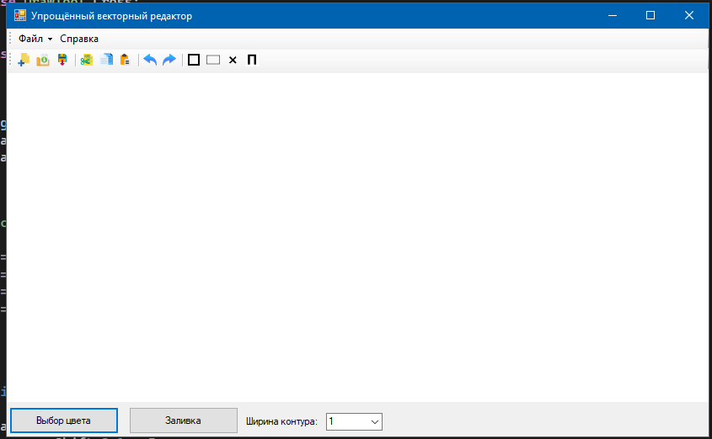
Рис.1 – Вид чистой формы
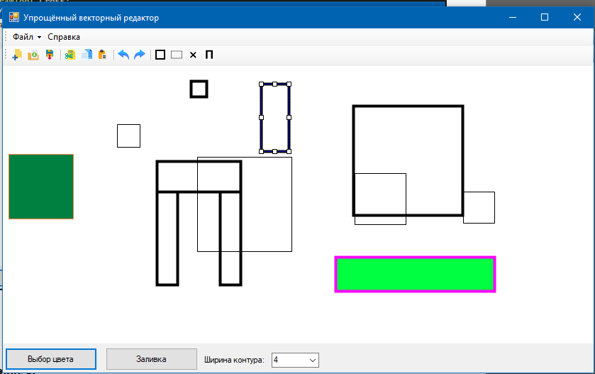
Рис.2 – Вид формы с элементами

